

**MASINDE MULIRO UNIVERSITY OF SCIENCE AND TECHNOLOGY**

**BIT 239**

**REPORT ON INDUSTRIAL TRAINING**

**BY**

**NAME: NASIMIYU BELINDA**

**REG NO: SIT/B/01-55796/2020**

**SUBMITTED IN PARTIAL FULFILMENT OF INDUTRIAL TRAINING AT MASINDE MULIRO UNIVERSITY OF SCIENCE AND TECHNOLOGY.**

# **DECLARATION**

I hereby declare that the details presented in this report are true as per the industrial training of the academic year 2021/2022 and have not been presented or published by any institution for the award of Bachelor’s Degree in Information Technology.

Name……………. …………………………………………………………………….

Signature ---------------

Date………………

## ACKNOWLEDGEMENT

First, I would like to express my sincere gratitude to God, almighty for his protection and mercies that led to successful completion of the industrial training.

I thank the school of Computing and informatics for organizing the training for us whereby through it, I was able to learn a lot that can help me fit in the current and the future technology. My humble gratitude goes to all facilitators, our lecturers who availed themselves without failure to help us through the industrial training. I thank them for their willingness to share their time and knowledge with us.

I am extremely grateful to my parents for their love, prayers, caring and sacrifices for educating and preparing me for my future. I am very much thankful to the Group Seven members for their support and teamwork throughout the training.

# Abstract

This is a detailed report on the school of computing and informatics annual second year industrial training for second year student’s class of 2021/2022. The report gives a brief background on the industrial training. It highlights the activities covered in each module in every week of the training that contains detailed information of what was covered in the modules plus the industrial visits summary report.

# Background information

The industrial training is an initiative by the Masinde Muliro University of science and technology’s school of computing and informatics that is usually conducted during the long holiday to all students enrolled in that school at their second year.

The industrial training is a program whose objectives are to equip the learners with the relevant skills and knowledge required in their field of studies and to make the students familiar with the practices that go on in the industries and bigger organizations since the activities that are done during the industrial training involve much of what is done in the industries in real life situations. It gives the students the overview of what is done in the industry thus its of great importance for the students during their industrial attachment and when they are employed.

Industrial attachment has helped me to learn ethics and conduct during the training period. I got the opportunity to interact with the trainers and freely since it was a free session.

Contents

**DECLARATION** ii

ACKNOWLEDGEMENT iii

Abstract iv

Background information 5

Chapter 1: Helpdesk and maintenance 1

1.1 Introduction: 1

Objectives of the module 1

Week 1 activities 1

Importance of maintenance 2

ASSEMBLING AND DISASSEMBLING A SYSTEM. 2

Week 2 activities 6

CHAPTER 2 10

MODULE 2: DATABASE SYSTEMS AND ADMINISTRATION 10

Objectives of this module 10

ASSIGNMENT 12

Stored procedures 13

Stored procedure syntax 13

Triggers 13

Syntax for creating triggers 14

Chapter 3 16

Module 3: System Administration 16

Objectives 16

WEEK 1 16

WEEK 2 17

**Chapter 4** 18

Module 4: Networking design and cabling 18

Objectives of the module 18

MODULE REQUIREMENTS 18

Networking practical’s 19

RJ45 CONNECTOR CLAMPING PROCEDURE. 20

STEPS WHEN TERMINATING THE PATCH PANEL 21

CAT6 UTP EIA/TIA 568A/B STRAIGHT AND CROSS-OVER WIRING & TESTING. 22

OBJECTIVES: 22

Subnetting 22

HOW TO CONFIGURE A ROUTER 24

**CHAPTER 5** 27

Module 5: Android 27

CHAPTER 6: 29

MODULE 6: INDUSTRIAL VISIT. 29

# Chapter 1: Helpdesk and maintenance

## 1.1 Introduction:

This chapter involves the summary of the knowledge and skills that was acquired during the first module of industrial training which was hardware maintenance and helpdesk user support. Such knowledge cannot be obtained in an ordinary class. The facilitators of this module were Mr. Kadima, Dr. Odoyo and other technical support staff.

## Objectives of the module

* To learn and identify both the internal and external parts of a computer.
* To understand different problems that may occur and how to solve them.
* To acquire technical skills and broaden the students technological knowledge
* Lastly to generally understand the helpdesk, user support and hardware maintenance.

## Week 1 activities

We were equipped with helpdesk skills involving activities like updating, logging and managing support calls, managing of the system and the clients and their contracts and so many activities that we noted down in our books. I also learnt about the various types of information technology helpdesk that are used and just mention a few; cloud-based help desk support software, open-source helpdesk software, on premise helpdesk, web helpdesk and so many others.

Our facilitators also empowered us on the constituents of a job card, invoices and customer request forms in different formats and the application of each. The Tutor was also of great benefit in equipping us with very important quantification/service pricing skills involving: Time taken and Level of input, in case of a job opportunity.

The module equipped us with knowledge on hardware and software components of a computer system and different activities one needs know about. We also got to learn the tools that are used in cleaning and maintenance.

The tools are, water,compressed air, screw drivers, bleachbit, Antivirus, blower, wipe disk cleaner among other tools

Common problems associated with computer are due to

* Running soft ware’s on an outdated operating system.
* Not being able maintains the computer.
* Installation of software’s that do not meet the system requirements.

These problems generally slow down the working of a computer and they need to be avoided. We identified various solutions to these problems and they include;

* Ensuring compatibility of software’s and programs before installation
* Running on updated operating system
* Regular maintenance i.e. Troubleshooting, blowing, installation of antivirus etc

## Importance of maintenance

Engaging in the practices above improves on the performance of the computer system and saves from costly maintenance.

Our facilitators also engaged us in how to perform maintenance and helpdesk on laptops, portable devices, CPU’S , printers and desktop computers.

## ASSEMBLING AND DISASSEMBLING A SYSTEM.

We assembled and dissembled the computer. We learnt of the procedure of assembling and disassembling the system unit. The following are the steps used during the practical.

1. Unplug the electronic cable, turn off the computer.
2. Unplug all the peripheral devices connected to attaches to the computer.
3. Open the case to access internal parts
4. Disconnect all the connectors i.e. IDE connectors.
5. Remove any stand-alone funs.
6. Disconnect the cables and remove storage devices.
7. Remove the memory (RAM) module by pushing the clips on both ends of the module.
8. Remove the power supply unit by unplugging the remaining connectors.
9. Remove any adapter/expansion cards from the motherboard
10. Disconnect all the cables from the motherboard.
11. Disconnect all the cables from the motherboard, then unscrew the motherboard from its frame by loosening each screw.

We also learnt of the precautions to note when and before carrying out assembling and disassembling of the system unit.

1. Make sure that the power is switched off to avoid being electrocuted.
2. Keep hands away from rotating/moving machine.
3. Handle RAMs properly to avoid discharging.
4. Bags should not be brought into a workshop as people can strip over them.
5. Be keen while removing the disks, CD-ROM, Processors, IDE connectors and do it gently.

After disassembling the system unit, we looked at the three types of the motherboard form factors. These includes;

ATX

Micro-ATX

Mini-ATX

We learnt about the computer POST (Power On Self-Test ) and its importance when booting a computer. POST is the process performed by firmware or software routines immediately after the computer or other digital electronic is powered on. It tests the computer to make sure it meets the necessary requirements and that all the hardware and software is working properly before starting the remainder of the boot process.

We examined the two processor types intel and AMD (Advanced Micro Devices) used in the PCs by looking at their main characteristics and their purposes. We compared the two processors and we were able to come up with the following;

* Intel is less expensive at a lower range while AMD processor is less expensive than intel at a higher range.
* Intel can heat up when used with clock speed Boost (14nm) while AMD is generally cooler due to smaller lithography.
* In Intel processor clock speed reaches and surpassed 5.0Ghz while in AMD processor clock speed can reach 5.0 GHz but results in more heat.

We also discussed the various methods and devices used for keeping the system cool. The following are the devices used to keep the system cool.

* Heat sink
* CPU fan
* Power supply fun
* Heat pipes
* Vapour chambers

Methods used to keep the system cool are;

* Keep your system away from vents and windows.
* Give your system some breathing room
* Close your system case properly.
* Add a memory cooling fan
* Check your system’s power supply fan
* Get a water-cooling kit.
* Upgrade your CPU fan
* Clean your fans regularly.

We also discussed the various memory modules.

* Trans flash memory module
* Single in-line memory module
* Dual in-line memory module.

We were taken through how, when and why it’s necessary to upgrade our memory.

* When – If your PC or laptop is flagging despite a fast CPU (if the RAM is slow)
* How

-check your computer’s current memory configurations and maximum memory capacity.

-select the best memory upgrade

-purchase new memory module

-install the module in your computer.

* Why

To improve the processing speed (improve performance).

To facilitate multiprocessing.

To avoid lagging of processes.

For better gaming and surfing.

We discussed the various cable interfaces used in a computer, hard drive interface standards. Under this we looked at the SATA, PATA, and the IDE interfaces.

SATA (Serial Attachment Advanced Technology Attachment) – is a bus interface that connects hard disk, optical drives.

PATA (Parallel Advanced Technology Attachment) – is a bus interface used for connecting secondary storage devices like hard disks, optical drives.

IDE (Integrated Drive Electronics) interface – is a standard type of connection for storage devices in a computer.

We discussed the memory architecture and its functions. We looked at the three levels of the Memory cache.

Level 1(Register)

Level 2(Cache memory)

Level 3(Main memory)

Finally, we learnt the periodic HDD maintenance. Under this, we looked at the tool used in the maintenance of the HDD. The tools were as follows;

The anti-virus program.

Updated OS

Defragmentation tools

File cleaner

Automatic disk updaters

Disk speed up apps.

## Week 2 activities

The second week of this module featured practical session on the theory learnt in week one. We had the opportunity to disassemble and compare the Dell and hp computers, identify the different parts and note the difference between them.

We were able to repair some of the pins and it was a successful activity. Another activity involved disassembly and study of a faulty hp laptop with a RAM specification of CDDR3 with a size specification of 4gb.

The main objective was to identify the parts deduce the problem which was found to be a faulty motherboard. It was the most technical of all the practices. The facilitator also engaged us in how to burn a CD using Ashampoo and Rufus. We were given a task to install Pentium 4 on the dell computers and it was successful but unfortunately didn’t manage to install visual basic an MS office 2013 couldn’t install due to incompatibility issues.

Below are images of my group disassembling a dell CPU, identifying he different parts and noting the down and then later on assembling it and powered it on.

We were also able to identify the pars that have been faced out in the latest machine.

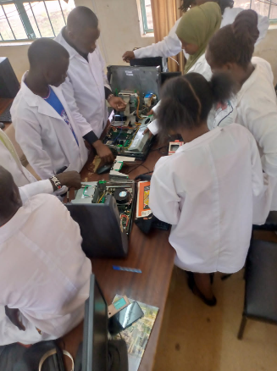

Disassembling of the machine

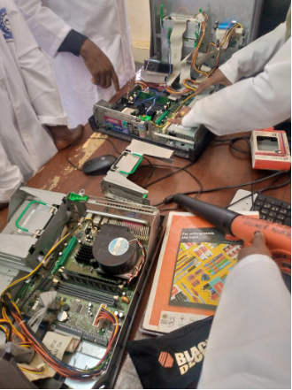

Identifying of the parts

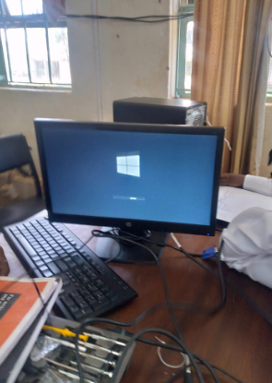

We successfully managed to assemble the parts back and connected the monitor and then powered it on. Gladly it was successfully accomplished.

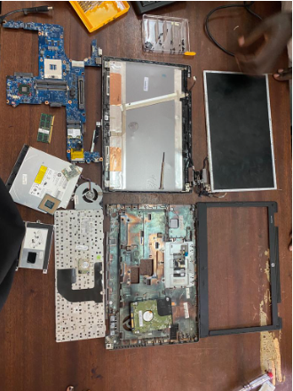

This was a faulty laptop that was brought in by one of the members, we decided to disassemble it during the practical lesson of maintaining and repairing a laptop.

We found out that it had **faulty motherboard** that couldn’t be fixed thus advised the owner to purchase another motherboard or either sell the spares and buy a new laptop.

# CHAPTER 2

## MODULE 2: DATABASE SYSTEMS AND ADMINISTRATION

This module took place on the 3rd and 4th week of industrial training. The facilitators of this module were Mr. Nahason Matoke and Dr. Raphael Angulu

## Objectives of this module

* To give students a theoretical base in Relational Database Management System (RDBMS).
* To guide students how to rate different RDBMS products in the market.
* To enable students, learn how to develop user requirements based on interactions with users.
* To acquaint oneself with the procedure of data normalization and rules applied during the process.
* To guide students on how to design a database using various design tools.

**N/B: At the end of this module, every group was supposed to come up with a complete functional database.**

Dr. Angulu introduced us to the basic concepts of a database and the various terminologies used in the database field. He also gave the importance of a database in an organization. A brief introduction of relational database management system followed thereafter. He taught us how to use the different software tools i.e. how to install and use NAVICAT premium, MYSQL WORKBENCH and most efficiently MYSQL server that was majorly used in this module. He was able to impact knowledge on how to code and connect java and the database with the help of the DB connector. We were also able to learn the different types of keys (primary keys, candidate, super, foreign, composite keys), defined the different types of integrity and other definitions. The facilitator taught us how to use Java FX and we learnt how to create a program and link it with the database for it save the data. Below is a successfully created registration form using python programming language.

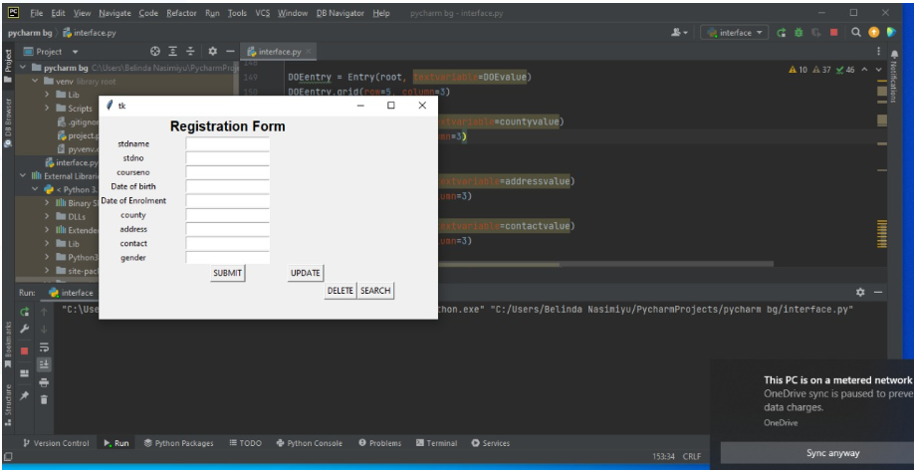

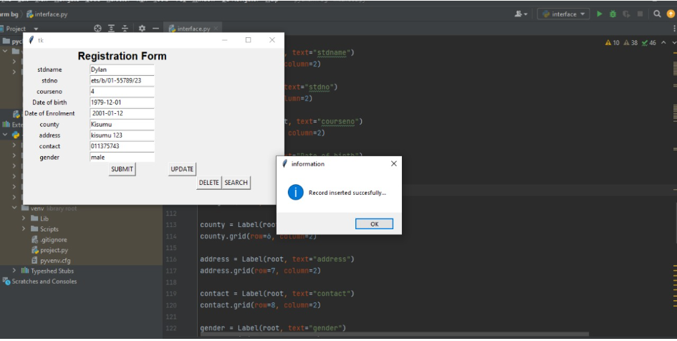

Another facilitator Mr. Matoke came and took us through creating of database, tables and the SQL clauses which include: DISTINCT, WHERE, AND/OR, IN, BETWEEN, LIKE, ORDERE by, GROUP by, COUNT and the HAVING clause. An assignment on the above was given and was worked on in groups and was completed successfully by each group except some who encountered challenges and were helped out by the facilitator. He briefly explained how to create and destroy various database objects such us schemas, tables and views and also create, test and call procedures. We were able to;

CREATE DATABASE and USE DATABASE Clauses

CREATE TABLE and DROP TABLE Clauses

CREATE VIEW and DROP VIEW Clauses

ALTER TABLE Clause

CHECK constraints – allows one to validate data before INSERT or UPDATE

## ASSIGNMENT

Each group was expected to carry out a detailed analysis on the MySQL and

Oracle indicating clearly how and where each is most suitably used and how they comply with

Edgar’s Codd’s Rules.

The facilitator also discussed the various types database management system that we as class went further to research more on them:

* Informix
* Sybase
* Oracle
* MySQL
* MySQL Server
* MariaDB
* Paradox
* Firebase
* NoSQL
* Mongo DB
* Informix
* Ms access

In the course of the week the facilitator took us through the stored programs which include the **stored procedures concept** and **triggers.**

## Stored procedures

A stored procedure is prepared SQL code that you can save, so the code can be reused over and over again. So if you have an SQL query that you write over and over again, save it as a stored procedure, and then just call it to execute it.

One can also pass parameters to a stored procedure, so that the stored procedure can act based on the parameter value(s) that is passed.

## Stored procedure syntax

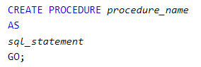

# Triggers

SQL Server triggers are special stored procedures that are executed automatically in response to the database object, database, and server events. SQL Server provides three type of triggers:

* Data manipulation language (DML) triggers which are invoked automatically in response to **INSERT**,**UPDATE**, and **DELETE** events against tables.
* Data definition language (DDL) triggers which fire in response to **CREATE**, **ALTER**, and **DROP** statements. **DDL statements** also fire in response to some system stored procedures that perform DDL-like operations.
* Logon triggers which fire in response to LOGON events

In this section, we learnt how to effectively use triggers in SQL Server.

* Creating a trigger in sql statement – show you how to create a trigger in response to insert and delete events.
* [Creating an INSTEAD OF trigger](https://www.sqlservertutorial.net/sql-server-triggers/sql-server-instead-of-trigger/) – learn about the INSTEAD OF trigger and its practical applications.
* [Creating a DDL trigger](https://www.sqlservertutorial.net/sql-server-triggers/sql-server-ddl-trigger/) – learn how to create a DDL trigger to monitor the changes made to the structures of database objects such as tables, views, and indexes.
* [Disabling triggers](https://www.sqlservertutorial.net/sql-server-triggers/sql-server-disable-trigger/) – learn how to disable a trigger of a table temporarily so that it does not fire when associated events occur.
* [Enabling triggers](https://www.sqlservertutorial.net/sql-server-triggers/sql-server-enable-trigger/) – show you how to enable a trigger.
* [Listing all triggers in SQL Server](https://www.sqlservertutorial.net/sql-server-triggers/sql-server-list-all-triggers/) – show you how to list all triggers in a SQL Server by querying data from the system triggers view.
* [Removing triggers](https://www.sqlservertutorial.net/sql-server-triggers/sql-server-drop-trigger/) – guide you how to drop one or more existing trigger.

## Syntax for creating triggers

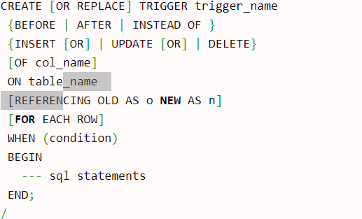

Below are screenshots on how to create users and assigning roles, granting privileges and global privileges as tackled in database administration

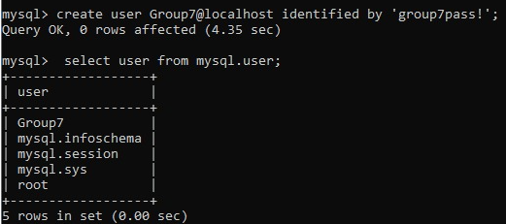



How to grant all privileges





How to create roles

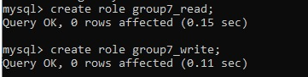

This are just but a few screenshot on part of the work we did in this module.

# Chapter 3

## Module 3: System Administration

This module was covered in the 5th and 6th week of the training. The facilitators were Mr. Rawlings Mulongo and Mr. Charles Muango. During the first week of the module, Mr. Muango took us through theoretical part of the system administration module. Later on Mr. Rawlings covered the practical part of the module.

## Objectives

1. To understand the role of the system administrator
2. To understand the basic commands of Linux and windows that are used in system administration and when to apply them.

## WEEK 1

During the first week, Mr. Charles Muango introduced the basics of System administration and definition of terms .We were able to identify the various types of system administrators and their roles, the types of operating systems that are used but majorly looked at ***windows*** and ***Linux.*** The tutor also explained as to why Linux Os was preferred than windows Os.

Reasons as to why Linux is used widely by systems admin

* It is more secure compared to windows
* Linux is lightweight and fast
* It is an open source software and cheaper to acquire
* Linux enables booting from USB even if BIOS does not support it
* Its stable, customizable and can run for even 5 years without failure

There are various types of administrators that are found in this field including:

* Telecommunication administrators- many companies use computer for communications, and it’s the responsibility of the telecommunications administrator to design and monitor those systems. They also provide maintenance by testing communication lines and overseeing to any damaged or malfunctioned equipment
* Network administrator- maintains the network infrastructure of a organization
* Database administrator- database admins set up databases for organizations and use database management software’s to figure out better ways to organize and analyze data. Just like network administrators they also monitor databases once they have been installed and provide maintenance when needed.
* Web administrator- they are specialists in maintaining websites which require constant observation and maintenance. They monitor the speed of the website and also approve content before its published.

Here are some of the windows maintain commands: **sfc /scannow,recimg, tasklist, powercfg, shutdown /r /o** among many other commands used by the administrator.

Other commands are:

1. WMIC csproduct get name- a command to get the brand name
2. SIMGR/PR- to check if your Os is genuine
3. DIR- to list folders
4. CD- how to navigate to the next directory

## WEEK 2

During this phase, Mr. Mulongo took us through the installation and creation of a virtual machine that was used to set up **WINDOWS SERVER** which was used for practical’s. The group leader was given the role of server administrator and assigned the task of creating users and assign privileges accordingly.

Activities engaged were:

* Creating users
* Granting and revoking privileges
* Creating and adding user domains
* Creating organizational units in the various groups and added the group members as users in the organizational units.
* How to access a server remotely
* We were also able to learn on how install software’s on other machines without physically accessing the machines as long as you’re operating on the server machine
* The tutor also educated us on the administrative tools i.e restricting use of

removable media, installation of program and changing of desktop backgrounds.

# **Chapter 4**

## Module 4: Networking design and cabling

The facilitators of this module were Dr. Jasper Ondulo who guided the theory sessions and Mr. Rawlings Mulongo who took us through the practical session.

## Objectives of the module

* To equip students a theoretical base knowledge in network infrastructure.
* To gain basic knowledge on various network operating systems available in the market.
* Have the ability to distinguish between the various network OS based on advantages and limitations of each and where they are suitably deployed.
* To learn and understand the standards that govern the network infrastructure

### MODULE REQUIREMENTS

* Crimper/clamper
* RJ-45 connectors
* UTP/ patch cable ( 3 pieces 2m each, CAT6)
* Patch panel (24-series/ports)
* Module
* Faceplate
* Cabinet (17u)
* Dumb switch
* Cable guide
* Router
* Punch down tool

The facilitator started by introducing us to the concept of networking. He briefly explained the different terminologies used in networking. We also able to cover the various networking and internetworking devices used in networks.

Different devices used in networking

1. Routers
2. Switches
3. Gateways
4. Repeaters
5. Hubs – has been phased out

We also looked at the types of communication media used in networking, they included:

* Twisted pair
  + Shielded twisted pair (STP).
  + Unshielded twisted pair (UTP).
* Fiber optics
* Coaxial cable
* Types of bridges-local network and wireless
* Routers-static and dynamic

The facilitator went on and introduced the concept of OSI model. The OSI model has 7 layers as mentioned below:

1. Physical layer – it’s the first layer and it provides the physical medium which bits are transmitted.
2. Data-Link layer- its used for error free transfer of data frames
3. Network layer- it’s the layer responsible for moving the packet from source to the destination
4. Transport layer- it provides reliable message delivery from process too process
5. Session layer- it’s the layer used to establish, manage and terminate the sessions.
6. Presentation layer- its responsible for translation, compression and encryption
7. Application layer-this layer provides service to the user

### Networking practical’s

The facilitator issued us with CAT5 cable and RJ45 and we were given an assignment of crimping working **crossover, straight through and rollover cables** which were thereafter to be tested if they’re working.

Color codes that were followed:

Straight through cable

* Orange white
* Orange
* Green white
* Blue
* Blue white
* Green
* Brown white
* Brown

Crossover color code

* Green white
* Green
* Orange white
* Blue
* Blue white
* Orange
* Brown
* Brown white

## RJ45 CONNECTOR CLAMPING PROCEDURE.

**Step1**: Using a Crimping Tool, trim the end of the cable you are terminating, to ensure that the ends of the conducting wires are even.

**Step2**: Being careful not to damage the inner conducting wires, strip off approximately 1 inch of the cable's jacket, using a modular crimping tool or a UTP cable stripper.

**Step3**: Separate the 4 twisted wire pairs from each other, and then unwind each pair, so that you end up with 8 individual wires. Flatten the wires out as much as possible, since they'll need to be very straight for proper insertion into the connector.

**Step4:** Holding the cable with the wire ends facing away from you. Moving from left to right, arrange the wires in a flat, side-by-side ribbon formation, placing them in the following order: white/orange, solid orange, white/green, solid blue, white/blue, solid green, white/brown, solid brown.

**Step5:** Holding the RJ45 connector so that its pins are facing away from you and the plug-clip side is facing down, carefully insert the flattened, arranged wires into the connector, pushing through until the wire ends are visible from the front plate.

**Step6:** Check to make sure that the wire ends visible on the front side are in the correct order; if not, remove them from the connector, rearrange into proper formation, and re-insert. Remember, once the connector is crimped onto the cable, it's permanent. If you realize that a mistake has been made in wire order after termination, you'll have to cut the connector off and start all over again!

**Step7:** Insert the prepared connector/cable assembly into the RJ45 slot in your crimping tool. Firmly squeeze the crimper's handles together until you can't go any further. Release the handles and repeat this step to ensure a proper crimp.

**Step8:** After the first termination is complete, repeat process on the opposite end of your cable.

We were also taken through the procedure o terminating a patch panel. The following are the steps we followed during the experiment.

## STEPS WHEN TERMINATING THE PATCH PANEL

**STEP1**: Using a Crimping Tool, trim the end of the cable you're terminating, to ensure that the ends of the conducting wires are even.

**STEP2**: Being careful not to damage the inner conducting wires, strip off approximately 1 inch of the cable's jacket, using a modular crimping tool or a UTP cable stripper.

**STEP3**: Separate the 4 twisted wire pairs from each other, and then unwind each pair, so that you end up with 8 individual wires. Flatten the wires out as much as possible, since they'll need to be very straight for proper insertion into the connector.

**NOTE:** There are two color patterns, T568A and T568B. Make sure to terminate both sides of the cable on the same pattern. If you have already terminated one side of the cable, look to see what pattern was used! If you have not already terminated, choose a standard that you will always use. Both patterns will produce the same results.

**STEP4:** place the cable wires into the slot on the patch panel. Make sure when you put them in the patch panel, you put them firmly so they don’t move before you punching down. Choose a port on the patch panel to begin terminating. Usually we start with the 1st port. Then insert each wire into its own slot. Don’t leave wires exposed too much or twisted to avoid signal loss.

**STEP5:** terminate the wires. Once you have all your wires in place, you have to take a punch down tool and punch down the wires into the patch panel. Push down the tool and cut the end of wire off. It is also OK to twist it off. After punching down the wire, your panel is looking nice and clean without surplus wires.

**STEP7:** inspect the wire. Once you’ve finished terminating the wires, use a cable tester to check if all the wires are correctly terminated.

**STEP8**: once you are done. Use a clip to prevent wires slipping out by accident.

**NOTE**: same procedure was applied to terminate the UTP cable cat6 to a module.

## CAT6 UTP EIA/TIA 568A/B STRAIGHT AND CROSS-OVER WIRING & TESTING.

### OBJECTIVES:

To understand the color coding standard of UTP cable

To create straight and crossover cable and test/verify its connectivity.

**Tools used**

1. Crimper/clamper
2. RJ-45 connectors
3. UTP/ Ethernet cable CAT6

**THE COLOR CODES FOR STANDARD UTP**

**Pin color codes for T568B in writing are as follows**:

|  |  |  |  |  |  |  |  |
| --- | --- | --- | --- | --- | --- | --- | --- |
| Pin1 | Pin2 | Pin3 | Pin4 | Pin5 | Pin6 | Pin7 | Pin8 |
| White/orange | Orange | White/Green | Blue | White/Blue | Green | White/Brown | Brown |

**Pin color codes for T568A in writing are as follows**:

**T568A STANDARD**

|  |  |  |  |  |  |  |  |
| --- | --- | --- | --- | --- | --- | --- | --- |
| Pin1 | Pin2 | Pin3 | Pin4 | Pin5 | Pin6 | Pin7 | Pin8 |
| White/Green | Green | White/Orange | Blue | White/Blue | Orange | White/Brown | Brown |

## Subnetting

**IP address**

We got to learn about IP addresses, IP addresses uniquely identifies machine in a network.

**IP versions**

1. IPV4 - It is used in Kenya

2. IPV6

**Classes of IP addresses**

* Class A ranges from 1 – 126
* Class B ranges from 128 – 191
* Class C ranges from 192 – 223
* Class D ranges from 224 – 254

#127 is used as a loop-back IP address and thus ignored in IP classification.

The network classes can also be determined by subnet mask as follows:

* Class A - has a subnet mask of 255.0.0.0
* Class B - has a subnet mask of 255.255.0.0
* Class C - has a subnet mask of 255.255.255.0

We installed a networking software called Packet Tracer. Using the packet tracer we were able to configure the switches and the routers. We learnt about the LAN and VLANS, we were able to create various VLANS using the Packet Tracer.

A VLAN (virtual LAN) is a subnetwork which can group together collections of devices on separate physical local area networks (LANs).

*Creation of VLAN on a switch.*

**Office 1 Switch**

S1(config)#vlan 10

S1(config-vlan)#exit

S1(config)#vlan 20

S1(config-vlan)#exit

S1(config)#

*Assigning VLAN Membership*

###### **Office 1 Switch**

S1(config)#interface fastEthernet 0/1

S1(config-if)#switchport access vlan 10

S1(config-if)#interface fastEthernet 0/2

S1(config-if)#switchport access vlan 20

###### **Office 2 Switch**

S2(config)#interface fastEthernet 0/1

S2(config-if)#switchport access vlan 10

S2(config-if)#interface fastEthernet 0/2

S2(config-if)#switchport access vlan 20

###### **Office 3 Switch**

S3(config)#interface fastEthernet 0/1

S3(config-if)#switchport access vlan 10

S3(config-if)#interface fastEthernet 0/2

S3(config-if)#switchport access vlan 20

*IP addressing in the VLAN and VLAN Trunk*

* Enter the VLAN 1 configuration mode with the interface vlan 1 global configuration command.
* Assign an IP address with the ip address IP_ADDRESS SUBNET_MASK interface subcommand.
* Enable the VLAN 1 interface with the no shutdown interface subcommand.
* (Optional) use the ip default-gateway IP_ADDRESS global configuration command to configure the default gateway.
* (Optional) Add the ip name-server IP_ADDRESS global configuration command to configure the DNS server.

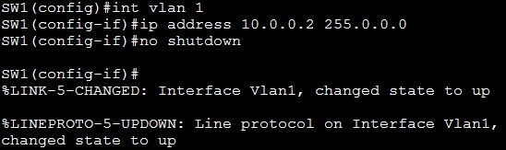

**N/B : devices on the same VLAN should be able to communicate with each other**

HOW TO CONFIGURE A ROUTER

**STEP1**: After downloading PuTTY, connect the console cable with Cisco Router or Swtich, double click putty.exe to execute it. Expand Connection > Serial. Enter the port number inside "Serial line to connect to" text box. The port number is COM4 in below example. The port number may be different in your computer. Enter the correct port number when you connect from your computer.

STEP2: Click Session and click "Serial" radio button. Verify whether you can see the port number and the baud rate (9600) you had selected before. Click "Open" to connect to Cisco Router or Switch IOS.

STEP3: PuTTY is connected to Cisco IOS and now you can configure, monitor or manage a Cisco Router or Switch using putty.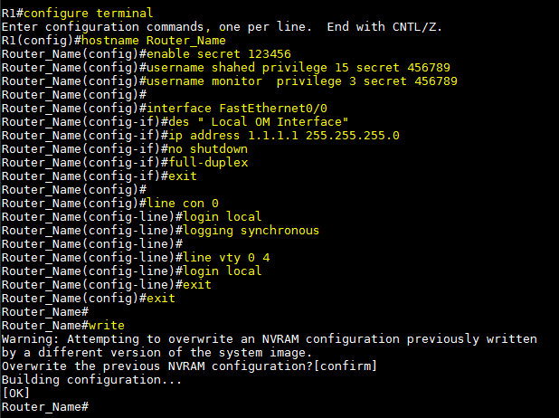

*Static routing:* This is a form of routing that occurs when a router uses a manually configured routing entry, rather than from dynamic traffic.

*Advantages of static routing*

* Static routing causes very little load on the CPU of the router, and produces no traffic to other routers.
* Static routing leaves the network administrator with full control over the routing behavior of the network.
* Static Routing is very easy to configure on small networks.

*Disadvantages of static routing*

* **Human error**: In many cases, static routes are manually configured. This increases the potential for input mistakes. Administrators can make mistakes and mistype in network information, or configure incorrect routing paths by mistake.
* **Fault tolerance:** Static routing is not fault tolerant. This means that when there is a change in the network or a failure occurs between two statically defined devices, traffic will not be re-routed. As a result, the network is unusable until the failure is repaired or the static route is manually reconfigured by an administrator.
* **Administrative distance:** Static routes typically take precedence over routes configured with a dynamic routing protocol. This means that static routes may prevent routing protocols from working as intended. A solution is to manually modify the administrative distance.
* **Administrative overhead:** Static routes must be configured on each router in the network(s). This configuration can take a long time if there are many routers. It also means that reconfiguration can be slow and inefficient.

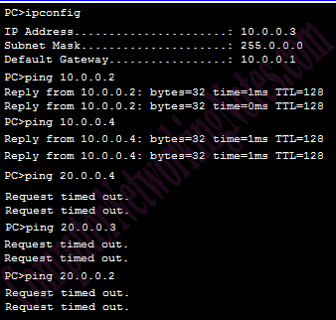

# **CHAPTER 5**

## Module 5: Android

This module was taught by Mr. Simiyu during the last week of our training. He started by introducing simple terms so that we familiarize ourselves with the module before learning the coding part of it. We able to learn that android is an open-source Os that and based on Linux kernel used for mobile devices such as smartphones and tablet computers etc.

Android was developed by google and later the Open Handset Alliance. Java and Kotlin languages are mainly used to write the android code even though other languages can be used.

*Some of the features of android are:-* flexible Gradle-based build system, a fast and feature-rich emulator, Instant Run to push changes to your running app without building a new APK among aother features…SMS and MMS are available, Supports audio/video WebMD etc. , Android OS basic screen provides a beautiful and intuitive user, it supports capturing screenshots etc.

#### Latest version of Android

Version 10: API LEVEL: 29(android 10)

Version 9: API LEVEL:28(name-pie)

Version 8.0-8.1 which is API 27(Oreo)

The software that we used during the training was Android studio

#### Project structure

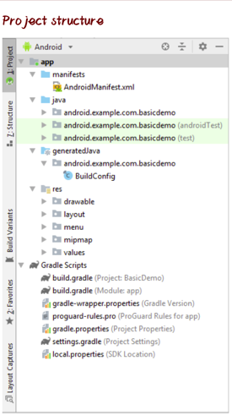

Some of the codes used to create apps were:

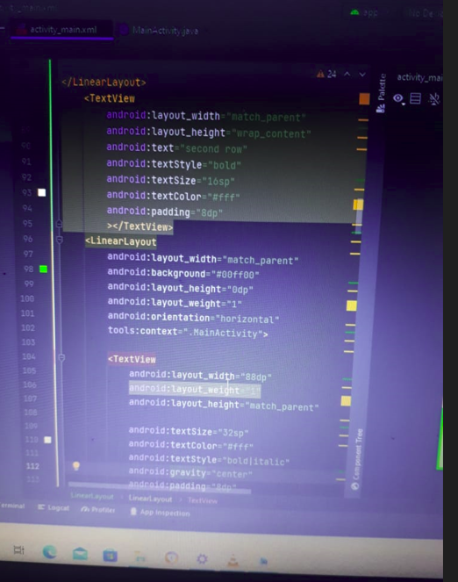

We were able to create several apps successfully and also linking one of them to database. Below are some of the codes we were able to learn during the practice.

# CHAPTER 6:

## MODULE 6: INDUSTRIAL VISIT.

Having gone through the industrial training, our next activity was to get exposed to what actually goes on in industries that deal with Information Technology.

#### OBJECTIVES.

* To learn the activities that take place in industries.
* To know the areas of employment in the industries.
* To get exposed more.

#### KENYA REVENUE AUTHORITY (KRA).

Kenya Revenue Authority (KRA) is the body that is charged with the responsibility of ensuring all taxpayers pay their taxes as required by the law. The main aim of the visit was to learn about the helpdesk services in the field of IT within the organization. On arrival, we were welcomed by the staff and after a brief introduction of them followed thereafter. Our visit facilitator then began by giving a brief history of KRA since its inception. She mentioned that the main headquarters of KRA are in Times Towers (Nairobi) but for the purpose of serving the country better, KRA operates with 5 regions in Kenya. The Southern region which was our destination mainly serves the coastal parts of the country.

Afterwards, we were shown how to create a KRA pin online since every taxpayer is required to have a KRA pin. The pin is unique and no two taxpayers can have the same pin. Their website is user friendly and for one to be issued with a pin they have to fill the mandatory fields when signing up. However, it was brought to our attention that the KRA system is interlinked with the NRB (National Registration Bureau) system in which when an applicant is filling in their details for KRA registration, their information automatically populates upon entering of the ID number which serves as the primary key in such a case. This technology is effective as it prevents incorrect information from being fed into the system.

Having learnt how to acquire a KRA pin, the next thing was to learn how to file returns. The issue of filing tax returns had been a menace to many Kenyans over the past month where all taxpayers were required to file their tax returns. We also learnt that there are different types of returns based on one’s occupational activity. Tax returns are supposed to be filed annually failure to which attracts a penalty. We were shown how to file the various returns which included NIL returns, PAYEE and returns for businesses. In the case of a business, we were shown how one can avoid unnecessary penalties when they wish to close the business temporarily and are therefore not expected to file any returns.

Through this knowledge, Computer Science and IT students can earn some income by rendering such services to the community. We were taught how their website operates with the issue of big data coming into place. This is because the KRA system is serving all Kenyans and as a result there are many end users feeding their data into the system. This data is of different type, variety and flows at a very high speed thus their system is in a position to sustain the big data. Since KRA deals with taxpayers, security to them is a major concern. We learnt of the measures they take to enhance security such as authentication among others.

We were told the essence of the ‘I” on the most of their names, the KRA facilitator said that the I on their services i.e., i-tax means that their services are digitized and automated.

We also saw the networking technology that they use in their organization. We got the opportunity to actually experience and be able to see most of the things we covered theoretically in class.

#### TELECOM COMPANY VISIT

In our academic tour to Telecom company, we learnt more about fiber optic communications system. Below are the important characteristics of fiber

* Low attenuation
* Light weight
* Long life expectancy
* Immunity to EMI/RFI and lightening damage
* Greater bandwidth
* Does not suffer problems related to electromagnetic phenomena i.e. tapping, leaking thus providing high security

We also had a chance to learn about the EAST AFRICA submarine cables

* TEAMS, Kenya UAE System- delivered Oct. 2009
* SEACOM –delivered Oct. 2009
* EASSY system- delivered May 2010
* LION system delivered May 2010